Access form Accessible Survey Builder

**Software Requirements Specification**

Version 1.0



**Group Id: F25PROJECTC0317**

**Supervisor Name: Abdullah Qamar**

**Revision History**

|  |  |  |  |
| --- | --- | --- | --- |
| **Date (dd/mm/yyyy)** | **Version** | **Description** | **Author** |
| 12/11/2025 | 1.0 | The Accessible Survey Builder is a web application that lets users easily create and manage surveys while making sure everyone, including people with disabilities, can use it. Most survey tools don’t really consider accessibility, so some people have a hard time participating. This project aims to make a simple and user-friendly platform where anyone can design surveys, collect answers, and generate reports. By focusing on accessibility, it helps everyone take part and makes the whole process easier and more inclusive. | BC220410808 |
|  |  |  |  |
|  |  |  |  |
|  |  |  |  |

**Table of Contents**

1. Scope (of the project) ……………………………. page 4
2. Functional Requirements Non-Functional requirements……………. page 5
3. Use Case Diagram…. page 6
4. Usage Scenarios…………………...page 7
5. Adopted Methodology………………………………...page 10
6. Work Plan (Use MS Project to create Schedule/Work Plan) …………………page 11

**SRS Document**

Scope of Project:

**Access Form** is specially designed for users who have disabilities (visual, hearing, motor, or cognitive), so they can easily create and fill forms according to their needs. This system includes all kinds of accessibility features, allowing users to build and complete forms based on their abilities. Nowadays, accessibility has become a major part of modern web design, and it is essential for every website or application to include it. As technology continues to advance, this serves as a major update for people with disabilities, enabling them to meet their needs more conveniently.

**Access Form** is a web-based survey builder that allows users to create and respond to different surveys. The platform provides a simple drag-and-drop interface through which form creators can add various types of questions such as multiple-choice questions, short answers, rating scales, and file upload options. After creating the form, it can be uploaded, and respondents can fill out and submit the same form easily.

Scope Boundaries:

**Access Form** includes three types of users. The **admin** can manage, edit, and delete the created forms and also view how many forms have been created or filled. The **Form Creator** can create any type of form by adding different types of questions according to their choice and can preview their created forms. The **Respondent** can fill out the given forms, but their access is limited to form submission only. The entire system is designed in such a way that all users, including those with different disabilities, can use it easily without any difficulty.

Some features are not included in this project, such as AI-based question generation, payment processing, support for specific desktop users, live chat support, and other advanced features. The main focus of this project is to make it lightweight, responsive, and accessible for every type of user.

1. **Included:**
   * Admin panel for managing users and forms.
   * Form Creator panel for building and sharing forms.
   * Respondent panel for completing surveys.
   * Accessibility features (keyboard navigation, ARIA labels, captions, alt text, high contrast).
2. **Excluded:**
   * AI-based question generation.
   * Payment integration or live chat.
   * Desktop-specific features.

Functional and non-Functional Requirements:

**FR1: User Role Management**

In this system, there will be three different user roles: **Admin, Form Creator, and Respondent**.  
The **Admin** will manage all users, manage all surveys, and ensure accessibility.  
The **Form Creator** will create forms and share them.  
The **Respondent** will fill the forms that are given to them.

**FR2: Form Creation & Customization**

This system provides a drag-and-drop interface and a manual interface through which the form creator can easily generate forms. The form creator can add different types of questions such as multiple choice, rating scale, user inputs, file uploads, and can reorder or delete them, and can preview the form they have created.

**FR3: Accessibility Feature Integration**

This system ensures accessibility for every user and includes all kinds of accessibility features such as keyboard navigation, screen reader compatibility (ARIA standards), high-contrast and dyslexia-friendly themes, alt text for every image, video captions, and voice integration.

**FR4: Analytics and Reporting Dashboard**

This system will provide an accessible dashboard to the form creator where they will be able to analyze the responses of the form they have created. All results will be filterable, and they can also be exported in Excel or CSV format.

**NFR1: Usability**

This interface is designed in such a way that it is friendly and easy to use for every user. Each user can navigate the interface according to their skill level. All instructions and labels are clear, which makes navigation easy.

**NFR2: Security**

All user information and responses will be securely stored through encryption. The admin will manage all users, and each user will handle their dashboard using a specific authorized login.

**NFR3: Compatibility**

This system will work on almost all major browsers (Chrome, Firefox, Edge) and will manage responsiveness according to every device (desktop, mobile, tablet). The forms and dashboard are managed according to different screen sizes, and accessibility is maintained.

**NFR4: Maintainability & Scalability**

The code is properly documented and modular, so if in the future anything needs to be added, it can be added easily. This code is also properly documented through the GitHub repository and available online.

Use Case Diagram(s):

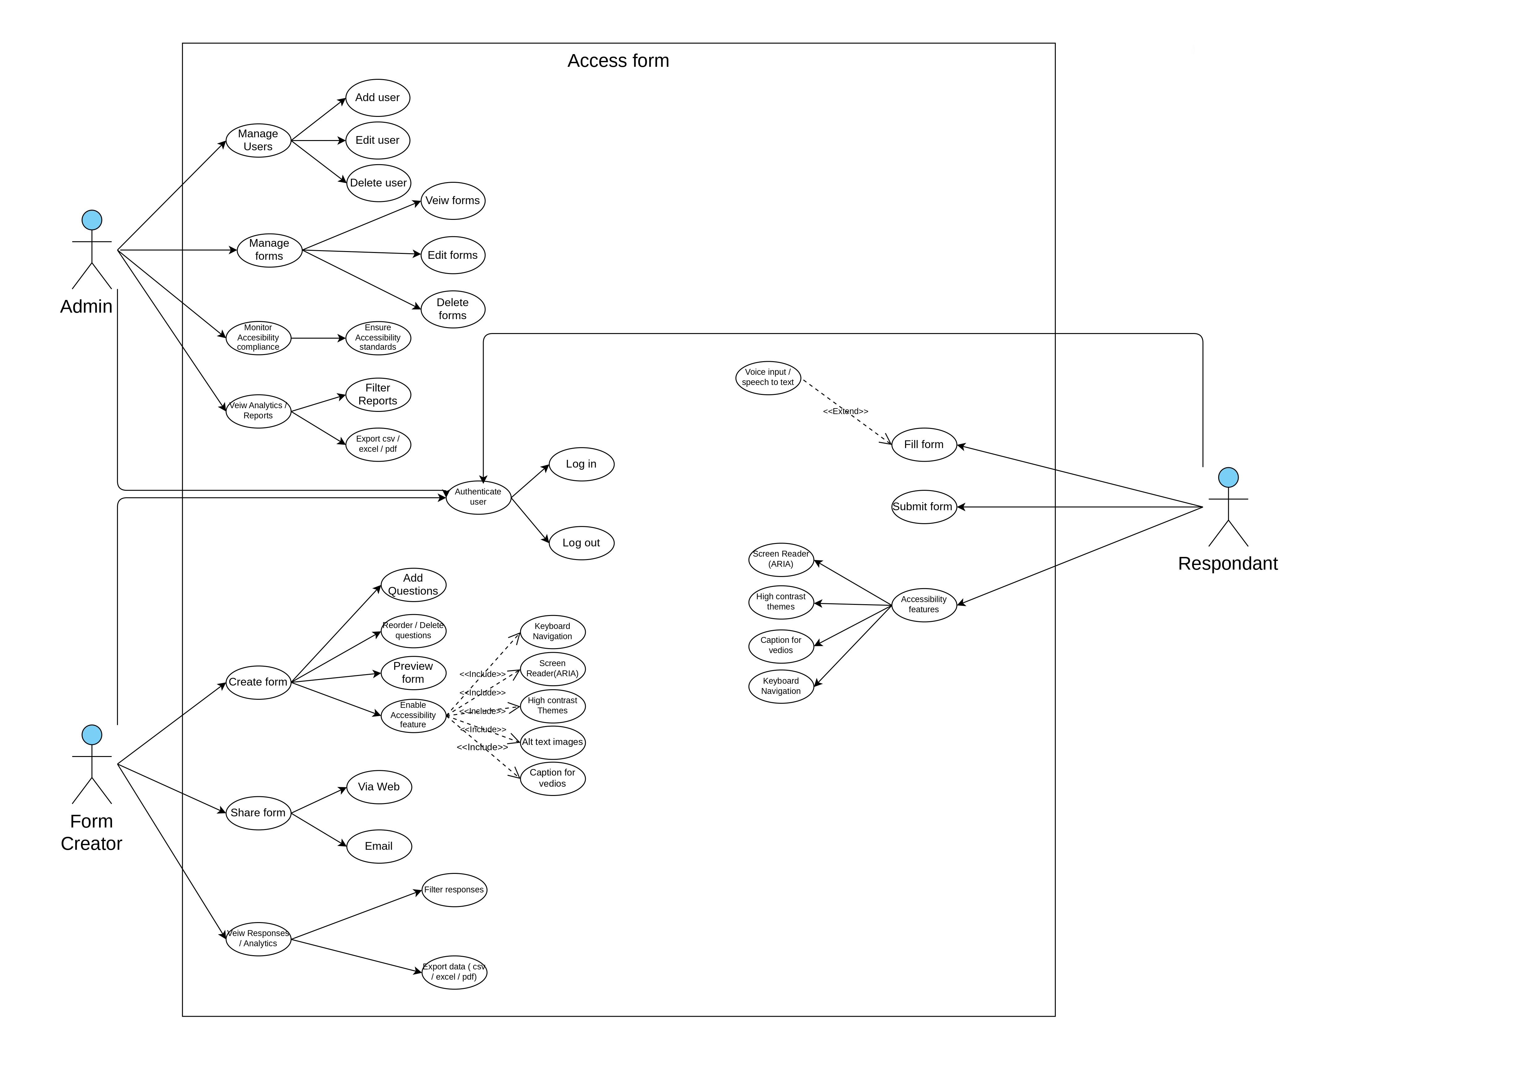

Figure 1.1

Usage Scenarios:

|  |  |  |  |  |  |  |  |  |  |
| --- | --- | --- | --- | --- | --- | --- | --- | --- | --- |
| **Use Case Title** | **Use Case ID** | **Actor** | **Actions** | **Description** | **Alternative Paths** | **Pre-Conditions** | **Post-Conditions** | **Exceptions** | **Author** |
| Manage Users | UC-ADM-01 | Admin | Add, edit, delete, view users | Admin manages all user accounts in the system. | Show error if user already exists or invalid data. | Admin must be logged in. | User list updated. | Database error, insufficient rights. | Bc220410808 |
| Manage Forms | UC-ADM-02 | Admin | View, edit, delete forms | Admin controls forms created by form creators. | Form not found show warning. | Admin logged in. | Updated form stored. | Unauthorized edit or delete failure. | Bc220410808 |
| Accessibility Compliance Review | UC-ADM-03 | Admin | Check ARIA labels, contrast, keyboard navigation | Admin ensures forms follow WCAG accessibility standards. | Suggest improvement if violations found. | Form must exist. | Form marked compliant/not compliant. | Accessibility tool failure. | Bc220410808 |
| View and Export Reports | UC-ADM-04 | Admin | Filter, export CSV/PDF/ Excel | Admin reviews analytics and system usage reports. | If no data show empty dashboard. | Data must exist. | Report downloaded or displayed. | Export error, analytics tool issue. | Bc220410808 |
| Login / Logout | UC-ADM-05 | Admin, Creator, Respondent | Enter credentials, authenticate, logout | System verifies identity and creates/discards session. | Incorrect password show error. | Account must exist. | Session created or closed. | Server timeout, authentication error. | Bc220410808 |
| Create Form | UC-FC-01 | Form Creator | Start new form | Creator begins a new survey form. | Save as draft if incomplete. | Creator must be logged in. | New form stored. | Database connection issue. | Bc220410808 |
| Manage Questions | UC-FC-02 | Form Creator | Add, edit, reorder, delete questions | Creator customizes form questions using builder tools. | Invalid question type error message. | Form must exist. | Question list updated. | Saving error, invalid input. | Bc220410808 |
| Apply Accessibility Features | UC-FC-03 | Form Creator | Enable alt text, high-contrast mode, ARIA attributes, captions | Ensures form is accessible for all users. | Warning if accessibility disabled. | Form created. | Accessibility settings saved. | Missing alt text or invalid captions. | Bc220410808 |
| Preview Form | UC-FC-04 | Form Creator | Preview final form | View how the form looks to respondents before publishing. | Preview in dark mode or mobile view. | Form must exist. | No change to system data. | Preview loading error. | Bc220410808 |
| Share Form | UC-FC-05 | Form Creator | Share via link, email | Makes form available to respondents. | Invalid email error message. | Form must be published. | Respondent receives link. | Email delivery failure. | Bc220410808 |
| View Responses & Analytics | UC-FC-06 | Form Creator | View responses, filter data, export results | Creator reviews submissions and visual analytics. | No responses show “No Data Available”. | At least one response must exist. | Data displayed or exported. | Analytics loading failure. | Bc220410808 |
| Fill Form | UC-RES-01 | Respondent | Answer questions via keyboard, mouse, voice input | Respondent fills form using chosen input method. | Fill using speech-to-text or keyboard-only navigation. | Valid form link must be available. | Responses stored temporarily. | Network drop, invalid input. | Bc220410808 |
| Submit Form | UC-RES-02 | Respondent | Submit completed form | Saves final answers into system. | Validation errors highlight missing fields. | All required fields must be filled. | Response stored successfully. | Server failure, timeout. | Bc220410808 |
| Use Accessibility Features | UC-RES-03 | Respondent | Enable ARIA reader, high contrast, captions | Provides accessible experience while filling form. | User can switch between modes (normal/contrast). | Form supports accessibility options. | Better user experience. | Browser not supporting feature. | Bc220410808 |

Adopted Methodology:

For the development of Access Form, I decided to use a Hybrid Software Development Methodology. Since this project focuses heavily on accessibility and requires constant feedback and improvements, relying on a single traditional model was not enough. Therefore, I combined the Prototyping Model with the Incremental Model to achieve both clarity in requirements and step-by-step development.

**Why This Combination?**

**1. Use of Prototyping Model**

Access Form deals with many accessibility-related features such as screen reader support, keyboard-only navigation, high-contrast themes, and alternative input methods (voice and SMS).  
These types of features cannot be finalized without testing early designs with real users, especially those with special accessibility needs.

Because of this, the Prototyping Model helped me create early sketches, mock-ups, and visual prototypes. After presenting these prototypes, I was able to take feedback and make improvements before actual development started.

**2. Use of Incremental Model**

The system has several major components like:

* Admin Panel
* Survey Builder
* Respondent Interface
* Voice/SMS response module
* Analytics Dashboard

Developing everything at once would increase the chances of errors. So, the Incremental Model allowed me to build the application in small sections, test each part separately, and gradually add more functionality in a controlled way.

**How the Methodology Was Applied**

**Phase 1: Requirement Analysis & Accessibility Review**

In the first stage, all requirements were collected, including accessibility guidelines such as WCAG 2.1 and ARIA standards.  
I identified what features need special attention, such as alt text, captions, screen reader behaviors, and color contrast.

**Phase 2: Building the Prototype**

A basic version of the application was created to show:

* survey builder layout
* question types
* accessibility options

This helped in understanding usability issues early. The prototype was reviewed and refined based on feedback.

**Phase 3: Incremental Development**

Once the prototype was approved, I started building the system in increments. Each increment focused on one major module:

**Increment 1: User Roles & Authentication**

Admin, Form Creator, and Respondent roles were created along with the login and registration system.

**Increment 2: Survey Builder**

This included drag-and-drop question creation and accessibility settings for each question.

**Increment 3: Response Collection**

Web-based responses, voice input, and SMS submission features were added.

**Increment 4: Accessible Analytics**

Charts, tables, and export options (CSV, Excel, PDF) were implemented with screen reader support.

**Increment 5: Final Accessibility Enhancements**

In this stage, I applied:

* ARIA attributes
* keyboard navigation testing
* color contrast adjustments
* screen reader validation

**Phase 4: Integration & Testing**

All modules were combined, and the entire system was tested thoroughly:

* accessibility testing
* functional testing
* mobile and browser compatibility testing

**Phase 5: Deployment & Documentation**

The final application was deployed on the server, and user manuals and testing reports were prepared.

**Benefits of This Approach**

* Accessibility issues were caught early due to prototypes.
* The incremental approach reduced risks and made development more manageable.
* User feedback was incorporated at every stage.
* Each module was tested individually, improving overall quality.
* The methodology provided flexibility to make changes without major disruptions.

**Conclusion**

By combining the Prototyping and Incremental Models, this Hybrid Methodology proved to be the best choice for Access Form. It supported continuous improvement, ensured accessibility compliance, and allowed the system to be built step by step in a controlled and user-focused manner.

Work Plan (Use MS Project to create Schedule/Work Plan)

